**Chirag H M-6373750(Superset)**

**Week2 PLSQL HANDS ON**

*CREATE TABLE Customers (*

*CustomerID NUMBER PRIMARY KEY,*

*Name VARCHAR2(100),*

*DOB DATE,*

*Balance NUMBER,*

*LastModified DATE*

*);*

*CREATE TABLE Accounts (*

*AccountID NUMBER PRIMARY KEY,*

*CustomerID NUMBER,*

*AccountType VARCHAR2(20),*

*Balance NUMBER,*

*LastModified DATE,*

*FOREIGN KEY (CustomerID) REFERENCES Customers(CustomerID)*

*);*

*CREATE TABLE Transactions (*

*TransactionID NUMBER PRIMARY KEY,*

*AccountID NUMBER,*

*TransactionDate DATE,*

*Amount NUMBER,*

*TransactionType VARCHAR2(10),*

*FOREIGN KEY (AccountID) REFERENCES Accounts(AccountID)*

*);*

*CREATE TABLE Loans (*

*LoanID NUMBER PRIMARY KEY,*

*CustomerID NUMBER,*

*LoanAmount NUMBER,*

*InterestRate NUMBER,*

*StartDate DATE,*

*EndDate DATE,*

*FOREIGN KEY (CustomerID) REFERENCES Customers(CustomerID)*

*);*

*CREATE TABLE Employees (*

*EmployeeID NUMBER PRIMARY KEY,*

*Name VARCHAR2(100),*

*Position VARCHAR2(50),*

*Salary NUMBER,*

*Department VARCHAR2(50),*

*HireDate DATE*

*);*

**Example Scripts for Sample Data Insertion**

*INSERT INTO Customers (CustomerID, Name, DOB, Balance, LastModified)*

*VALUES (1, 'John Doe', TO_DATE('1985-05-15', 'YYYY-MM-DD'), 1000, SYSDATE);*

*INSERT INTO Customers (CustomerID, Name, DOB, Balance, LastModified)*

*VALUES (2, 'Jane Smith', TO_DATE('1990-07-20', 'YYYY-MM-DD'), 1500, SYSDATE);*

*INSERT INTO Accounts (AccountID, CustomerID, AccountType, Balance, LastModified)*

*VALUES (1, 1, 'Savings', 1000, SYSDATE);*

*INSERT INTO Accounts (AccountID, CustomerID, AccountType, Balance, LastModified)*

*VALUES (2, 2, 'Checking', 1500, SYSDATE);*

*INSERT INTO Transactions (TransactionID, AccountID, TransactionDate, Amount, TransactionType)*

*VALUES (1, 1, SYSDATE, 200, 'Deposit');*

*INSERT INTO Transactions (TransactionID, AccountID, TransactionDate, Amount, TransactionType)*

*VALUES (2, 2, SYSDATE, 300, 'Withdrawal');*

*INSERT INTO Loans (LoanID, CustomerID, LoanAmount, InterestRate, StartDate, EndDate)*

*VALUES (1, 1, 5000, 5, SYSDATE, ADD_MONTHS(SYSDATE, 60));*

*INSERT INTO Employees (EmployeeID, Name, Position, Salary, Department, HireDate)*

*VALUES (1, 'Alice Johnson', 'Manager', 70000, 'HR', TO_DATE('2015-06-15', 'YYYY-MM-DD'));*

*INSERT INTO Employees (EmployeeID, Name, Position, Salary, Department, HireDate)*

*VALUES (2, 'Bob Brown', 'Developer', 60000, 'IT', TO_DATE('2017-03-20', 'YYYY-MM-DD'));*

**Exercise 1: Control Structures**

**Scenario 1:** The bank wants to apply a discount to loan interest rates for customers above 60 years old.

* + **Question:** Write a PL/SQL block that loops through all customers, checks their age, and if they are above 60, apply a 1% discount to their current loan interest rates.

**Scenario 2:** A customer can be promoted to VIP status based on their balance.

* + **Question:** Write a PL/SQL block that iterates through all customers and sets a flag IsVIP to TRUE for those with a balance over $10,000.

**Scenario 3:** The bank wants to send reminders to customers whose loans are due within the next 30 days.

* + **Question:** Write a PL/SQL block that fetches all loans due in the next 30 days and prints a reminder message for each customer.

**Scenario 1 solution with code :**

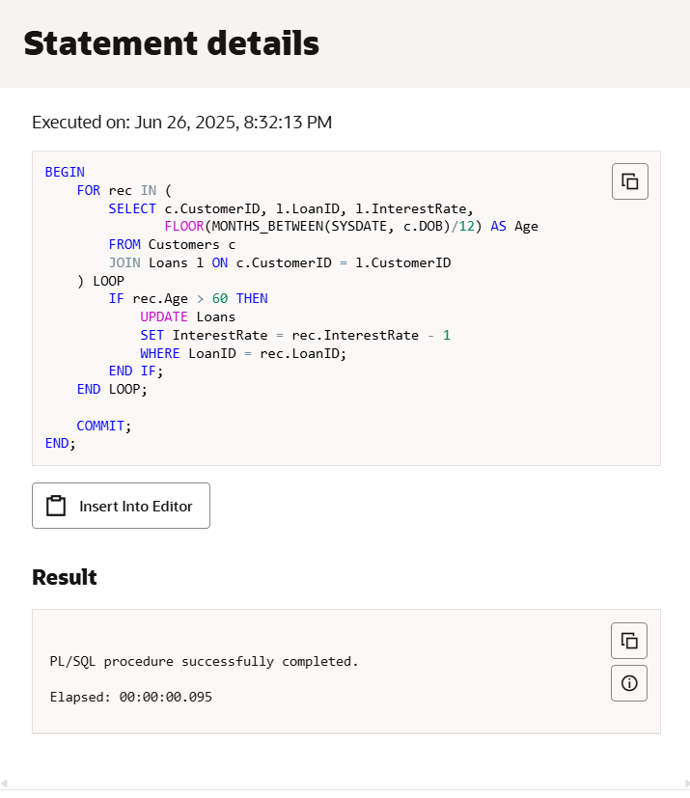

**Scenario 2: Promote Customers to VIP (Balance > 10,000)**

ALTER TABLE Customers ADD IsVIP CHAR(1);

(Adds a new column to store VIP status)

**Solution for scenario 2:**

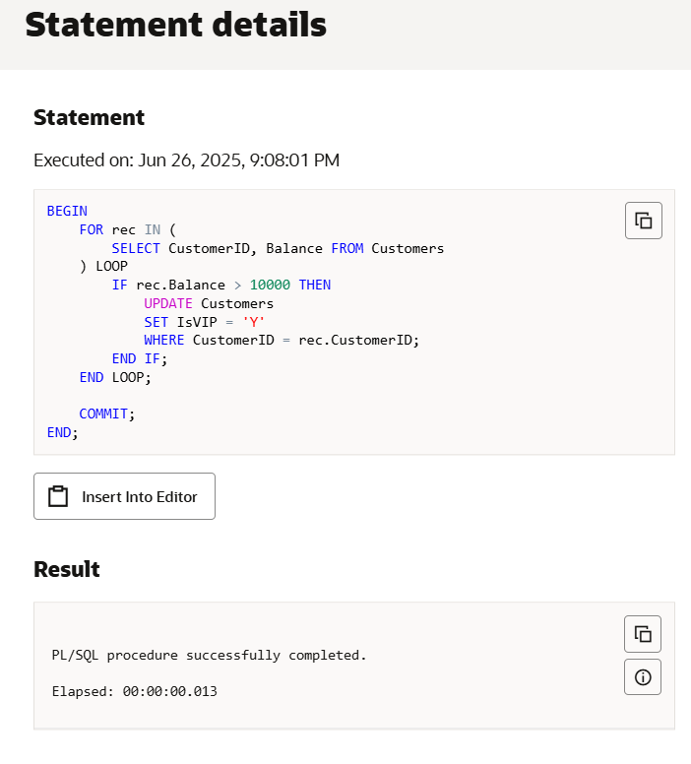

**Scenario 3: Send Loan Due Reminders**

SET SERVEROUTPUT ON ; (This enables printing messages on screen)

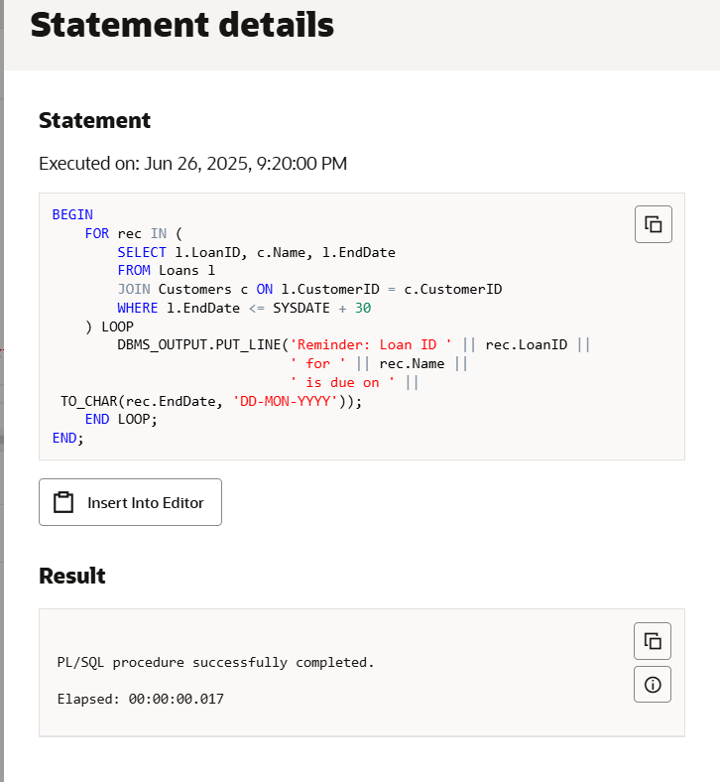

**Exercise 3: Stored Procedures**

**Scenario 1:** The bank needs to process monthly interest for all savings accounts.

* + **Question:** Write a stored procedure **ProcessMonthlyInterest** that calculates and updates the balance of all savings accounts by applying an interest rate of 1% to the current balance.

**Scenario 2:** The bank wants to implement a bonus scheme for employees based on their performance.

* + **Question:** Write a stored procedure **UpdateEmployeeBonus** that updates the salary of employees in a given department by adding a bonus percentage passed as a parameter.

**Scenario 3:** Customers should be able to transfer funds between their accounts.

* + **Question:** Write a stored procedure **TransferFunds** that transfers a specified amount from one account to another, checking that the source account has sufficient balance before making the transfer.

**Solution for scenario 1:**

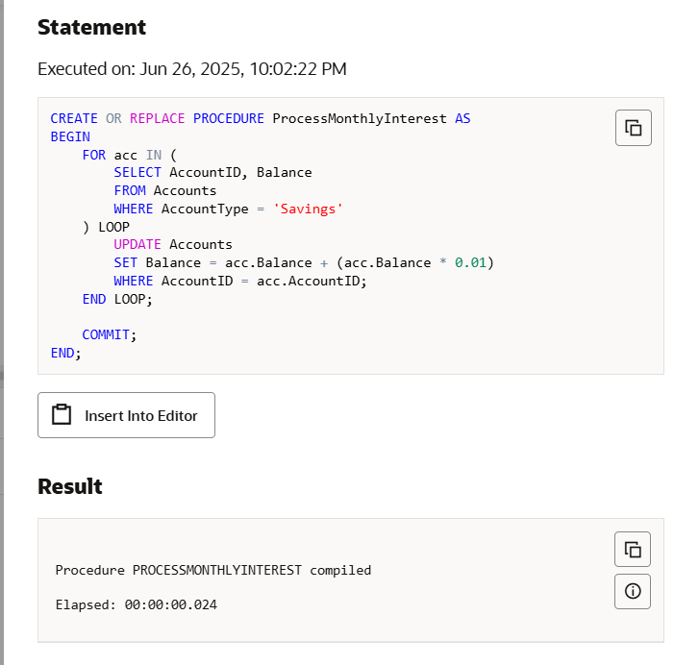

**Changes in database:**

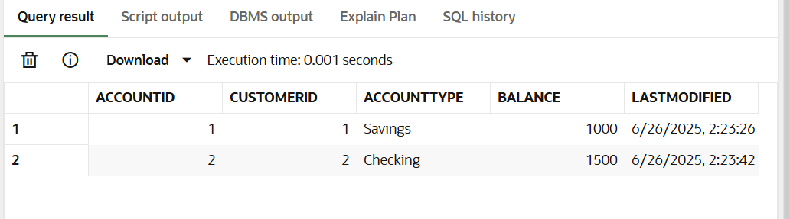

**Solution for scenario 2:**

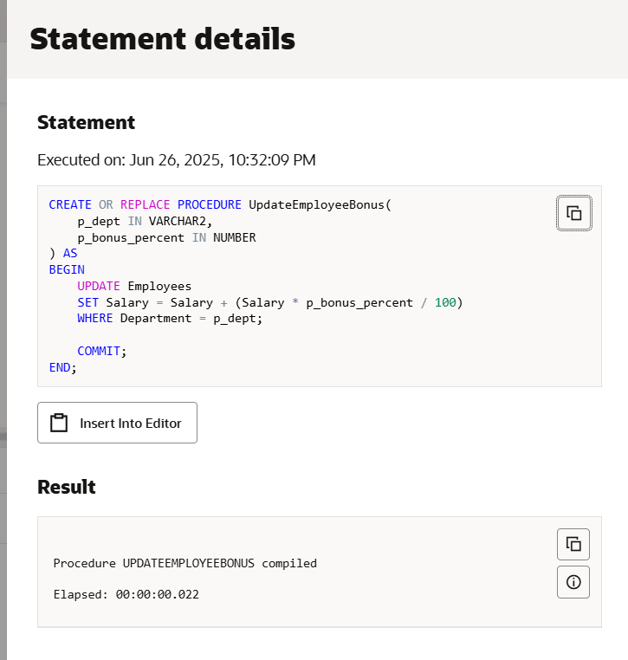

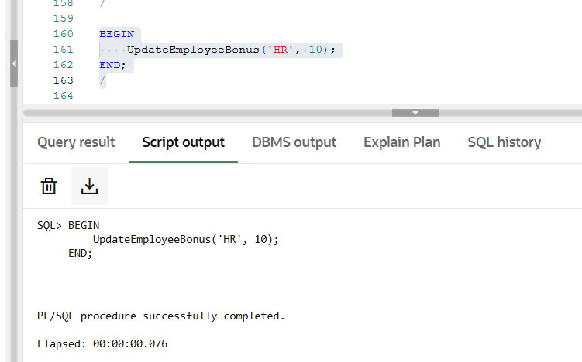

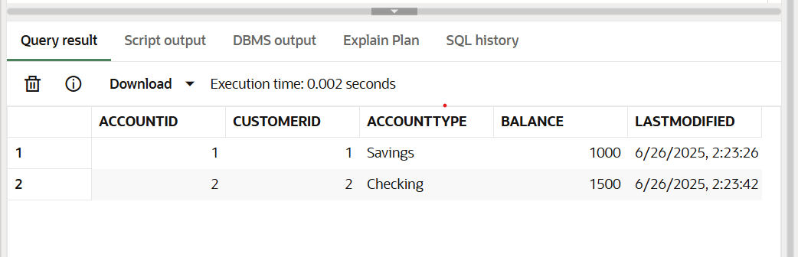

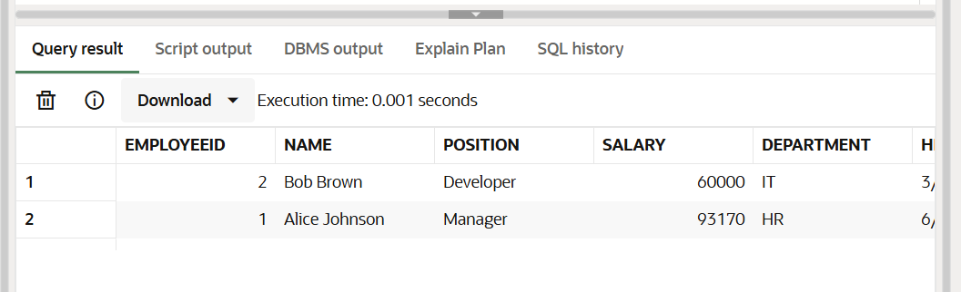

**Solution for scenario 3:**

CREATE OR REPLACE PROCEDURE TransferFunds(

    p_from IN NUMBER,

    p_to IN NUMBER,

    p_amount IN NUMBER

) AS

    v_balance NUMBER;

BEGIN

    -- Check balance of source account

    SELECT Balance INTO v_balance FROM Accounts WHERE AccountID = p_from;

    IF v_balance < p_amount THEN

        RAISE_APPLICATION_ERROR(-20001, 'Insufficient funds.');

    ELSE

        -- Deduct from source

        UPDATE Accounts

        SET Balance = Balance - p_amount

        WHERE AccountID = p_from;

        -- Add to destination

        UPDATE Accounts

        SET Balance = Balance + p_amount

        WHERE AccountID = p_to;

        COMMIT;

    END IF;

END;

/

